Finding our Carter Family Ancestors
By Thomas and Wanda Carter Phelps
Jan 20 2018
Prologue

By the 16th and 17th centuries, many Carter families had achieved both civil and social prominence in England, and yet the origin of the family name, as with so many others, had its roots in utilitarian everyday life. The name "Carter" can be found in English records almost as often as the names Smith or Brown. Until the early 20th century every village was supplied with those whose occupation it was to transport goods to and from markets by wagon, and they were known as "carters". So, it's not surprising that "Carter" became a common surname among many people unrelated by blood, but whose forefathers had followed the carter's trade, when surnames became hereditary in the 14th and 15th centuries. There were, therefore, many families working side by side in the same townships with the surname Carter who were not related. To make matters more confusing for the genealogist, the number of given names was limited, mainly to those of Christian saints and national heroes. There was a profusion of Thomas, Richard, Henry, William and John Carters; and many of these parents would give the same name to more than one of their children. This was also found true in our Phelps/Volp family. Four generations of Georg Volp’s were found in Sindringen, Germany. They were sometimes recorded as Georg the “Old” and Georg the “Young” to distinguish between taxes paid.
You can see how difficult it might be to trace our Carter family of Blount County, TN back to its source in England. At first it seemed impossible but soon the pathway was found and here’s how it all happened:

The STORY

The easiest part of an ancestry search is to start with today’s families and work back through history toward the beginning. Therefore, we started with Wanda’s father, Daniel Boone Carter.
Several years ago, when he applied for social security, there was some confusion about his actual birthday. It was determined from public records that he was actually seven years older than he had thought all of his adult life. It was determined that he was born February 2, 1897. He died on November 6, 1980. Much other information has been collected on Daniel and other members of the Carter family but this document will be limited to the quest of finding the history of the family and not the total family story. All the information collected, including names, dates, pictures and stories can be see on-line at the family website and the address is shown at the end of this paper.

Moving on to Daniel’s father, Thomas Franklin Carter (He was known as “Frank”), we immediately hit a wall. Very little was known about his past and we could find very little in public records. According to his daughter, Pearl Carter, Thomas Franklin’s mother left him when he was very young. They thought that his parents were probably from Georgia. She also said that he had 24 children by three different wives. According to tales of his son, Daniel Boone Carter, Frank, had possibly killed someone in an argument, quite possibly a person of color. To avoid the law, he moved out of state. This story was confirmed by Randy Kincannon (from conversations with Pearl Carter in the 1970s). The persons name was thought to be William Dodson/Dotson. None of this could be substantiated and with no other leads on his family, we turned to using yDNA.

A yDNA test is a genealogical blood test which is used to explore a man's patrilineal or direct father's-line ancestry. The Y chromosome, like the patrilineal surname, passes down virtually unchanged from father to son. To use this method of research, we had to use a male member of Wanda’s family. Her brother, Ralph Carter, agreed and it took a couple of months to get the results. A “Carter Project” was established at Family Tree DNA where the blood test was done. This enabled them to alert us when a matching donor was found. We researched on the internet and spread the word regarding our yDNA project, encouraging those who might be searching for a Carter match, to test at FTDNA. During the next couple of months, several Carter’s were tested but none matched Ralph. Then, a family member of Orman Guy Carter, Jr who lives near Nashville, TN found our website and emailed us because they had a missing family member with the name, T F Carter who was born on Oglethorpe, GA in 1841. Our research had not uncovered this particular Carter mainly because there were numerous Thomas Carters in the records even with the middle initial F. We were busy researching all the more obvious Thomas Carters but having no success.

Remembering the comment by Pearl Carter that our Thomas Franklin Carter probably came from GA suggested that this might be our ancestor but we knew that the final proof would be with a yDNA test. We offered to have the yDNA test kit sent and Orman Guy Carter Jr agreed to provide the saliva sample. After a couple of months, FTDNA provided the data that showed a direct hit! The test showed that Ralph and Guy matched on a perfect 37 of 37 points on the yDNA test. This means that they have a very close common ancestor.

We now know from an 1860 Federal Census that Elijah G Carter(1817-1878) had eleven children. Our Thomas Franklin Carter was one of these children. Also, his yDNA match, Orman Guy Carter, Jr, descended from another son, Charles Edward Carter, Sr. A Relationship Chart is shown in the next page.

Guy Carter’s family has been researching for years and have traced their roots back to a Thomas Carter who was born in 1701 in England. They were building out their line but had this one particular person that they could not locate who they thought might be our Thomas Franklin Carter and it turned out they were correct.

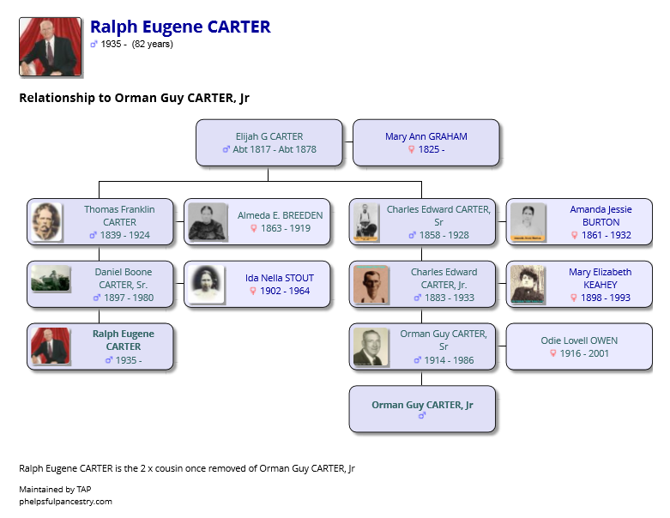

The Orman Guy Carter family shared a family story about Thomas and his three brothers who fought in the Civil War. At this time the Carter family lived in Mississippi and most of the family and neighbors fought for the Confederacy. However, Thomas and another brother joined the Union Army. This created a major conflict in the family and when the war was over, one “Union” brother came home, collected some personal belongings and moved to Missouri to avoid the hatred that was present. They never heard from him again. The other union brother, Thomas (only known as T F Carter), did not return home and was thought to have been killed during the war. We now know that he decided to come to Tennessee, probably, like his brother, to avoid the family conflict. Also, like his brother, he apparently never contact his family again. His wife and children apparently never knew of this situation or at least it was not passed down to later generations.

The headstone for Thomas F Carter shows he was born on Mar 12, 1845. The date in the 1850 census suggest he was born in 1841. His age was probably inadvertently given to the 1850 TN Census taker by some household member. Mistakes of this type were not uncommon during the period. For example, a military report shows his age as 18 on March 16, 1864 suggesting he was born in 1846. Another military report shows him 18 on July 12, 1865 suggesting he was born in 1847.

July 12, 1865 and on March 16, 1864 (that would make the year of birth 1847. Another example of confused dates was when his son, Daniel Boone Carter found out late in life that he was 4 years older than he had thought all his life. One thing for sure, we know that he and Charles Edward Carte Sr were brothers.

The Guy Carter family provided their additional family research results and we have confirmed most of this with our own research. There is one connection which we continue to explore. Many people researching this line have accepted this link but we think more work is necessary to clearly validate the connection. We continue this work today.

Our Carter story with all the details is presented on the website: www.phelpsfulpancestry.com

Tom and Wanda Carter Phelps
Jan 18, 2018

