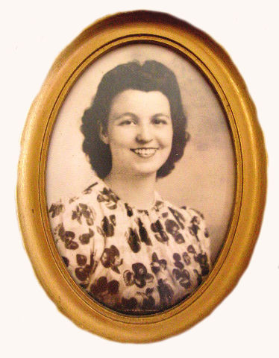

Juanita Maye Phelps Jackson, a long time resident of Manchester, TN, passed away October 8, 2020 at the NHC Tullahoma Nursing Home in Tullahoma, TN. Juanita was 96 years young. She was born April 5, 1924 in Maryville, TN, into the loving family of William Esco Phelps (died at age 92) and Rosa Honor Davis Phelps (died at age 98). She was one of eight children consisting of four brothers and three sisters.

She was preceded in death by her husband, William Jackson Jr and her two daugh-ters, Rebecca Lynn Haggard and Tressa Karen Rickles. She is survived by her brother, Darrell Phelps who is 99 years young of Maryville, TN, grandson Bill Rickles of Tullahoma, TN, granddaughter Emily Delight Haggard of Manchester, TN, and several nieces and nephews.

Juanita met and fell in love with William Jackson Jr. of Coalfield, TN while work-ing at the Aluminum Company of America in Alcoa, TN. They married on May 18, 1944, and Bill soon boarded the USS Torrance and was off to fight in the Pacif-ic, during WWII. Juanita changed jobs to help in the war effort by working on the secret “Manhattan Project” at Oak Ridge Tn. After the war they settled in Coal-field, TN where their two daughters were born. They later moved to Polk County, TN where Bill partnered with his father-in-law, William Esco Phelps, to operate a 400 acre farm. When Mr Phelps retired and moved back to Maryville, TN, Bill and Juanita moved to Manchester, TN where Bill worked at Arnold Air Force Base as a pipefitter. They were very active at the Westwood Baptist Church in Manchester, TN for many years.

Juanita was a loving wife, mother, grandmother and just a wonderful person. She especially enjoyed gardening and music. She played several musical instruments and frequently preformed on stage with her granddaughter, Joy Leann Haggard (deceased).

Coffee County Funeral Chapel has been entrusted with the arrangements. Juanita will be buried beside her husband in the Rose Hill Memorial Gardens Cemetery in Tullahoma, TN.

Memorial gifts may be made to the Foundation for Peripheral Neuropathy http://www.foundationforpn.org

